The attendance system project for Maungawhau college would be a multi-functional, form-based website application. It is designed to automate the process of taking student attendance and generating associated functions. This project allows administrators to manage students, lecturers, classes, courses, etc. Lecturers can enter student attendance, and students can also view their attendance on the system.

To implement the development of this project, appropriate programming languages and data access technologies should be chosen considerably. For this project, I will research Java and python programming languages and evaluate MySQL database and SQLite database.

Java or Python, which is more suitable?

To begin with, let us know some simple background of these two languages.

Java was developed by James Gosling at Sun Microsystems, and released in 1995 as a part of Sun Microsystem’s Java Platform. Java transformed the web experience from simple text pages to pages with video and animation. While Python was conceived in the late 1980s by Guido van Rossum at Centrum Wiskunde & Informatica (CWI) in the Netherlands as a successor to the ABC programming language, which was inspired by SETL, capable of exception handling and interfacing with the Amoeba operating system.

Undoubtedly, Python and Java are the two most popular programming languages in the digital marketplace because of their efficiency, robustness, and versatility.

Since 2003, Python has consistently ranked in the top ten most popular programming languages in the [TIOBE Programming Community Index](https://en.wikipedia.org/wiki/TIOBE_Programming_Community_Index) where, as of October 2021, it is the most popular language (ahead of Java, and C). It was selected Programming Language of the Year (for "the highest rise in ratings in a year") in 2007, 2010, 2018, and 2020 (the only language to do so four times).

Python has become more popular than Java. Google Trends shows Python’s fame rose above Java in 2017:

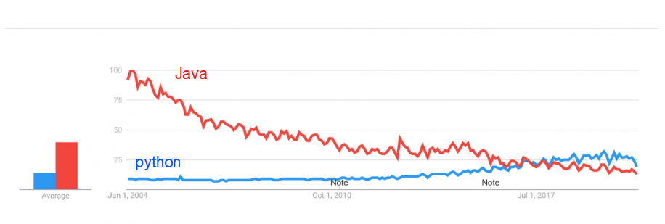

Now, let us search for some differences.

Firstly, Java is a statically typed and compiled language, and Python is a dynamically typed and interpreted language.

Being a statically typed language, Java catches errors in the early stage only (before the execution of the program).  Whereas, being a dynamically typed language, sometimes Python encounters unexpected errors. But everything comes with its own strengths and weaknesses. Unlike Java, Python allows you to change its variable type in the code later in the program, ensuring flexibility and scalability.

This single difference makes Java faster at runtime and easier to debug, but Python is easier to use and easier to read. With Python, developers don’t need to think about software engineering constraints. Therefore they can focus more on building heuristically algorithms. related to machine learning, artificial intelligence, data science, etc.

Secondly, because Python is an interpreted language, its syntax is more concise than Java, making getting started easier and testing programs on the fly quick and easy. Java emphasizes more syntax whereas Python follows the indentation process. For instance, if you forget to insert a semicolon or curly brackets within the code (wherever it is required) when using Java, then your code will show an error. On the other hand, Python doesn’t require you to add semicolons or curly brackets within the code. In Python, you just need to take care of the indentation. The indentation format of Python increases its code readability.

Thirdly, both languages can be used in API interactions and for machine learning. Java is better developed for building web applications. Python’s Flask library is still only able to build the basics to a Python-based UI but is great for creating a Python back-end with an API endpoint.

Therefore, considering the program complexity and function requirement, I prefer to use python language on its Django framework, and with some excellent data processing libraries such as Pandas.

For this project, I could use Django MVT (Model-View-Template) structure. The model is going to act as the interface of the data, the view is the user interface, what you see in your browser when you render a website, and the template consists of static parts of the desired HTML output as well as some special syntax describing how dynamic content will be inserted.

With Django, I could create some models, such as Student Model, and then write the functions and methods in the View, and lastly render the static parts of the HTML page.

SQLite database and MySQL database, which one should I choose?

SQLite is an open-source project available in the public domain. It is a serverless database and is self-contained. This is also referred to as an embedded database which means the DB engine runs as a part of the app. SQLite is an in-process library that implements a self-contained, serverless, zero-configuration, transactional SQL database engine. The code for SQLite is in the public domain and is thus free for use for any purpose, commercial or private. SQLite is the most widely deployed database in the world with more applications than we can count, including several high-profile projects.

On the other hand, MySQL is an open-source project which is owned by Oracle. It requires a server to run, and a client and server architecture to interact over a network.

As SQLite does not have any specific user management functionality and hence is not suitable for multiple user access. While MySQL has a well-constructed user management system which can handle multiple users and grant various levels of permission.

SQLite is suitable for smaller databases. As the database grows the memory requirement also gets larger while using SQLite, and performance optimization is harder when using SQLite. This has a few write constraints. On the contrary, MySQL is easily scalable and can handle a bigger database with less effort.

Therefore, for this project, I will choose SQLite database because it is suitable for basic development and testing, and more effective than MySQL.

In conclusion, to develop the attendance system project for Maungawhau college, Python programming language with Django framework and SQLite database is more proper to choose.